Bhartiyam International School
Periodic Assessment – 1 (2022-23) Subject: EVS (Set-1)
Class: I
Date: 12/07/2022 Max. Mark: 20
Name: Roll No: Duration: 1 hr

Instructions:
- All the questions are compulsory.
- Attempt all the questions in neat and clean handwriting.
A. Attempt the multiple choice questions. (1X3=3) 1.How many sense organs do we have?
a) 3 b) 7 c) 5
2. Ears help us to –
- smell b) hear c) see
3. Identify the correct spelling of given picture-
a) tongeu b) tongue c) tngeeu
B. Match the pictures with their spellings. (1X3=3)
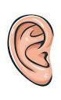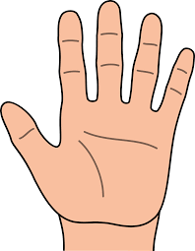
1. a) hand

2. b) nose

`
3. c) ear

C. Write ‘T’ for true and ‘F’ for false statement. (1X4=4)
1. Mouth helps us to see.

2. Teeth help us to eat.

3. Hand helps us to clap.

4. Skin helps us to jump.

D. Fill in the blanks. (1X4=4)

1. My name is .
2. I am years old.
3. The things we like are called our things.
4. First name is also known as your .
E. Answer the following questions. (2X3=6)
1. Name the sense organs.

2. How do our hands help us?

3. Name your favorite food item.

